Task- Launch an EC2 instance (Linux and Windows) along with a web server. Then, create an EBS volume of 5 GB, attach it to an EC2 machine (Linux and Windows), and take a snapshot. Finally, create an EBS volume using the taken snapshot.

Step 1: Create two EBS volume of 5GB
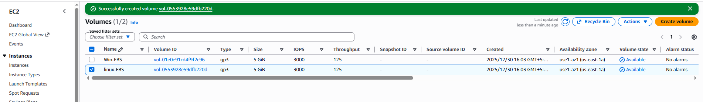

Step 2: Launch a linux ec2 instance with web server
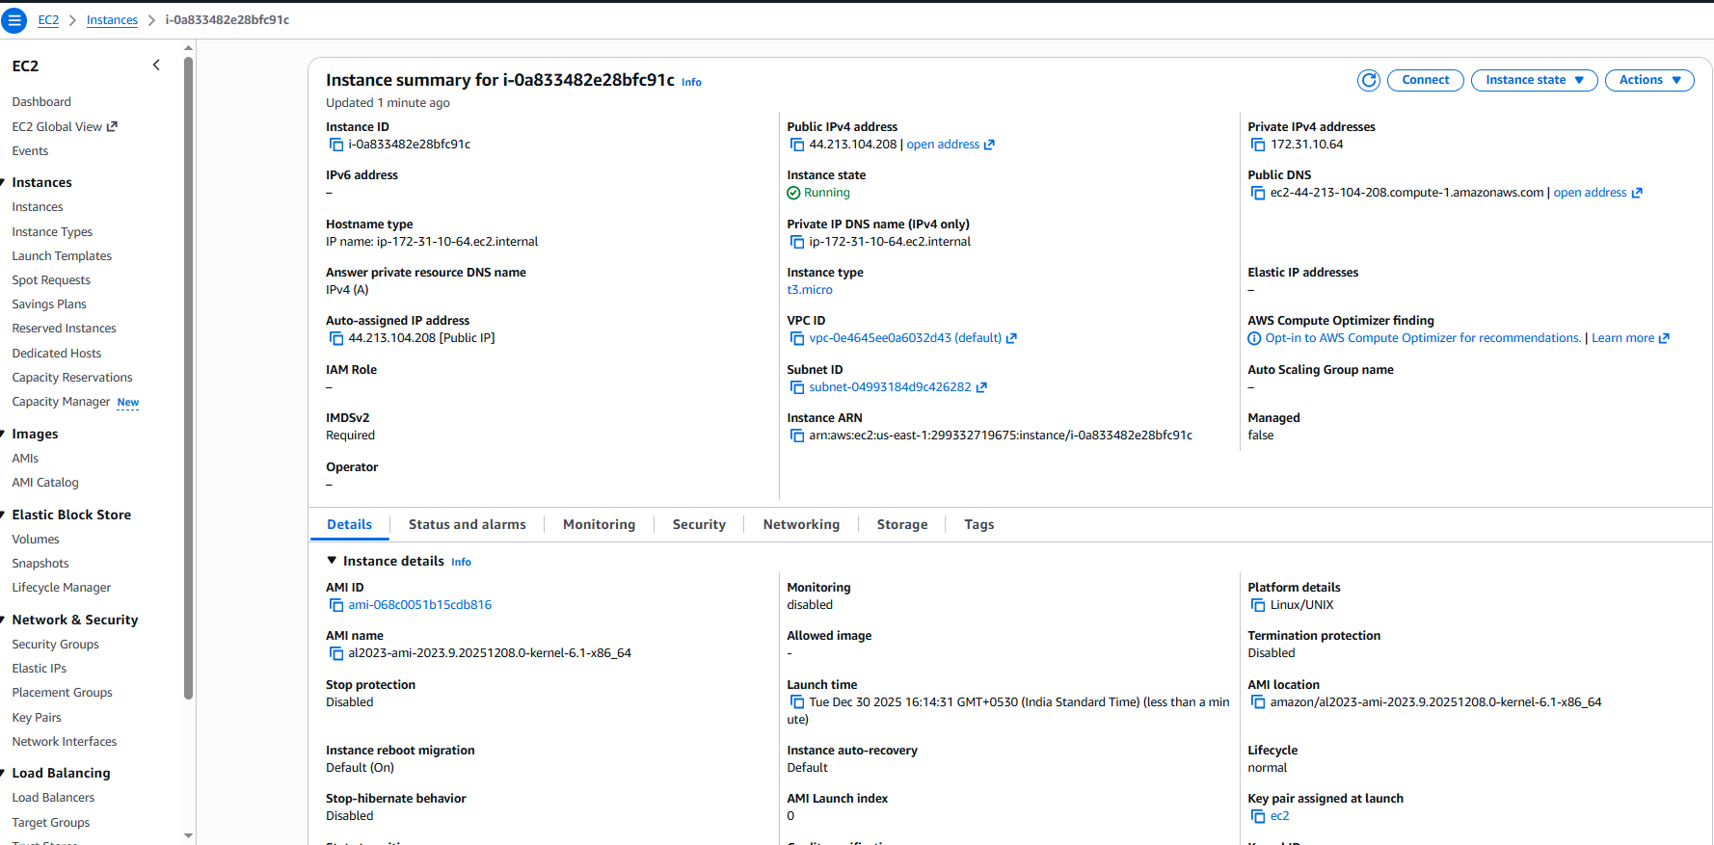
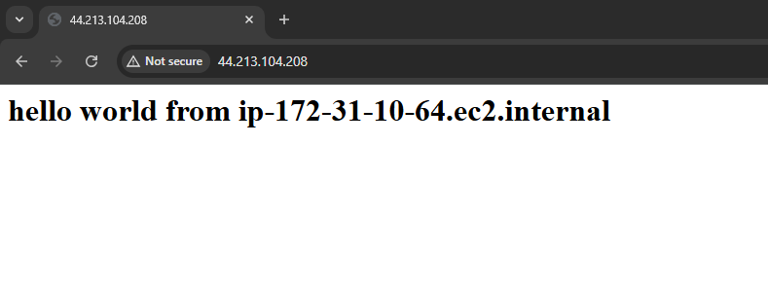Step 3: Launch a windows ec2 machine
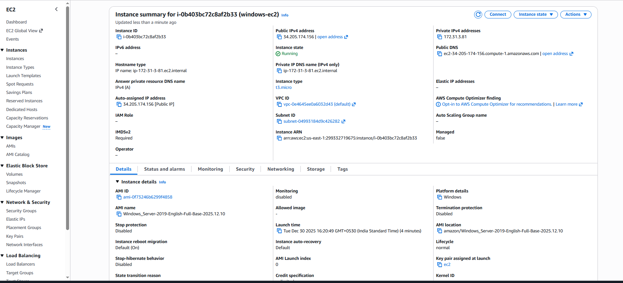

Step 4: Take RDP of ec2 instance and install web server
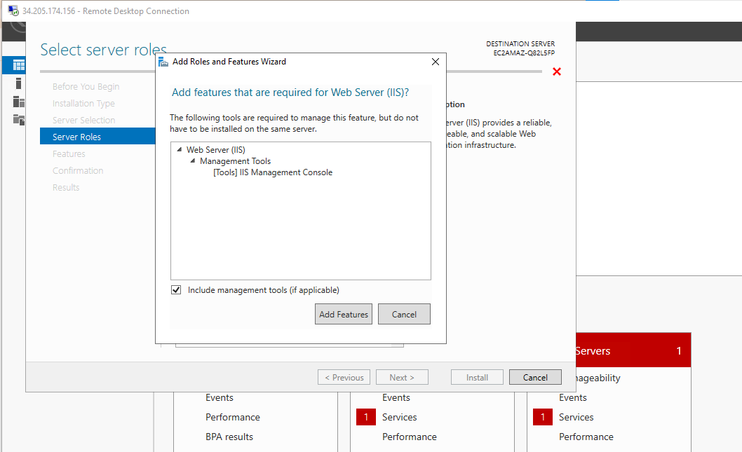
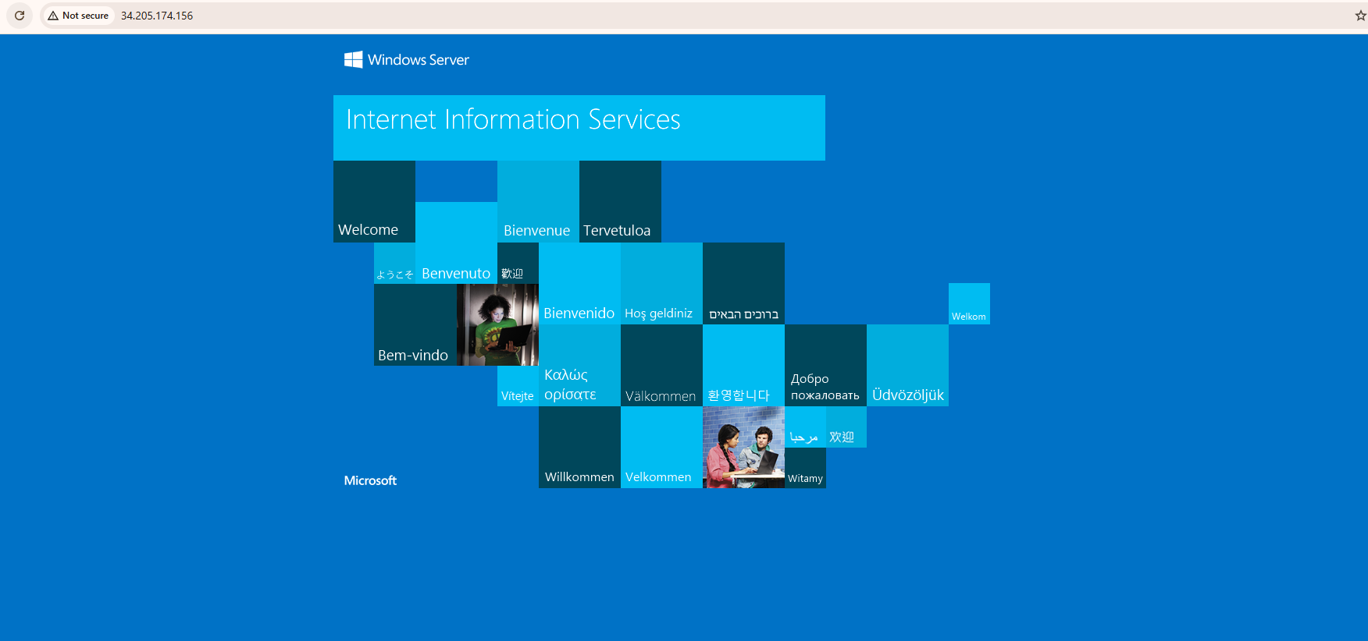

Step 5: Attach the volumes to the Ec2 instances
On windows
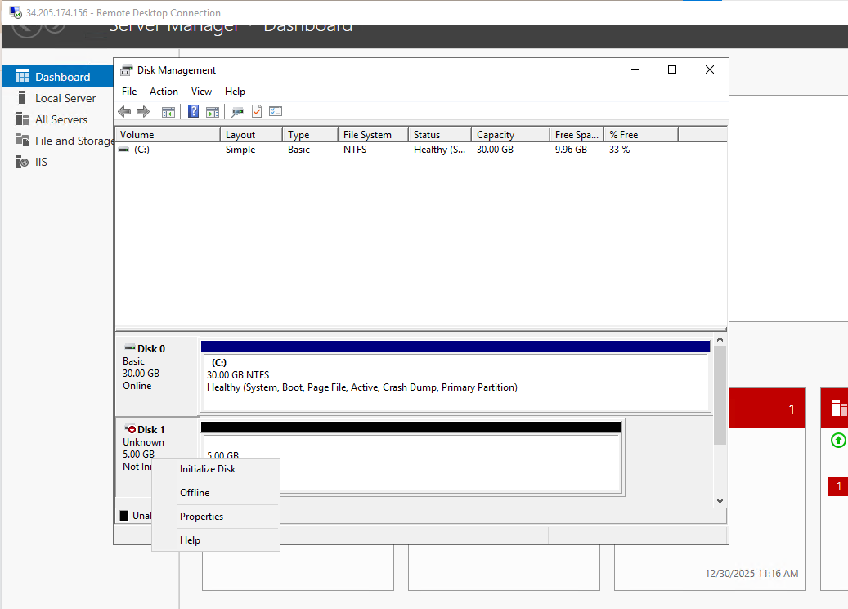
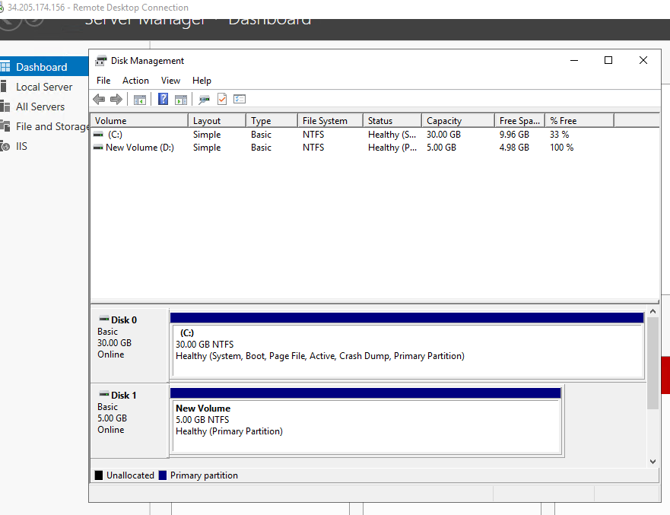

On linux
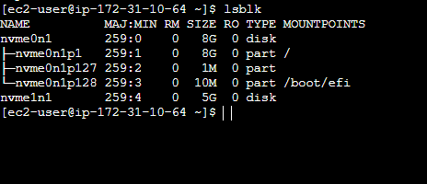

Step 6: Take snapshot
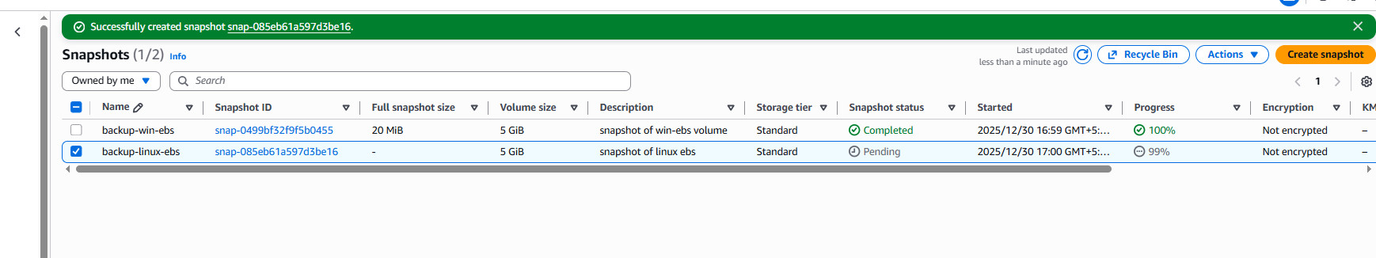

Step 7: Create volume from the snapshots
